MARVIN’S GARDEN CLEAN ENERGY
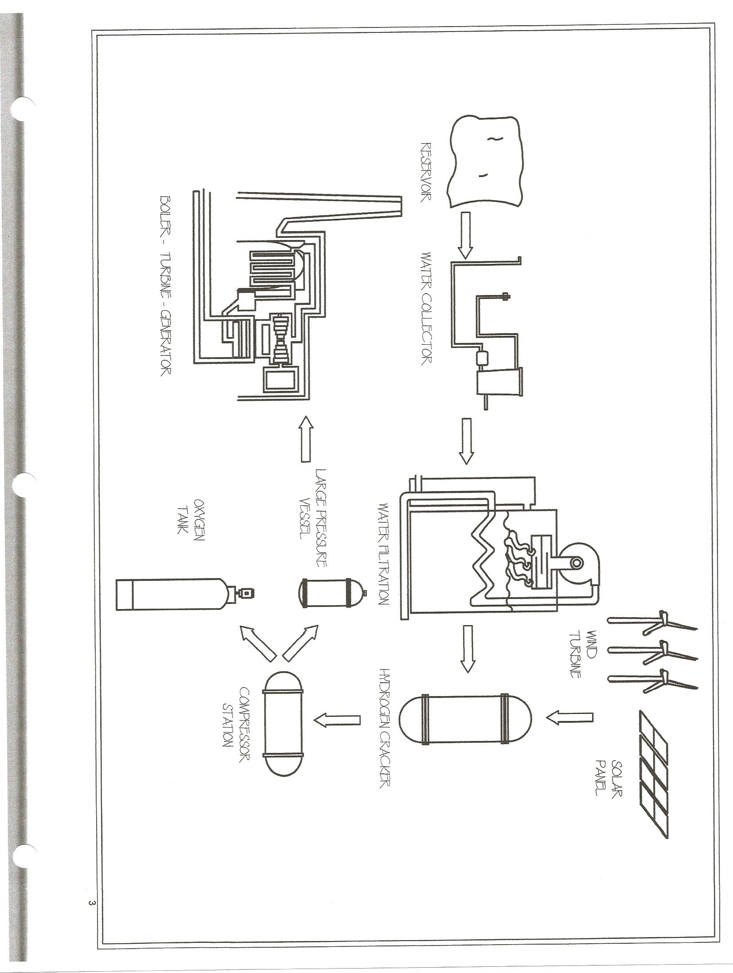

Wind and Solar Power Conversion To Base-Load Clean Energy

Today’s base-load consumer electricity is mainly supplied through the burning of fossil fuels to run steam turbine engines connected to large electric generators. The fossil fuels used mainly are coal doused with diesel fuel or natural gas enhanced with butane. The coal or natural gas is burned in a boiler to produce steam which is used to spin the turbine which spins the generator.
The method for providing the coal in sufficient quantities to guarantee continuous base-load electricity is mining, processing and delivering it onsite. Also, large quantities of diesel fuel are delivered and stored onsite. The method for providing natural gas in sufficient quantities to guarantee continuous base-load electricity is drilling for, extracting and processing the natural gas. Also, large quantities of butane are injected and delivered onsite. Both coal and natural gas have to be delivered in large quantities on site to ensure non-interruption of base-load electricity production. The never ending residual costs of these fossil fuels are enormous.
In today’s world there is an ever increasing objection to the pollution and carbon emissions generated by the burning of fossil fuels. I believe that the time is right to bring to light an idea which I have been sitting on since 1995. I have worked in the petroleum industry since the fall of 1990 and this epiphany came to me one afternoon in early 1995. The technologies needed to bring this idea to fruition have been in existence for more than 20 years but to my knowledge have not yet been combined for use in this fashion.
Wind power and Solar power have been used to supplement electricity to the power grids for a number of years but because of their very nature are unreliable due to the inconsistency of the supply of wind and sun (see the many rants of John Gormley on this subject.) It occurred to me that just as we mine coal and process natural gas to use as the fuel source being burned in order to produce electricity we could also use wind and solar to mine hydrogen and oxygen from water to use as the fuel source being burned to produce electricity.
Engineers know through calculations that it takes an X amount of coal plus diesel fuel or natural gas plus butane in order to produce a base-load Y amount of minimum average electrical power generation every month. It is possible for engineers to calculate how many wind turbines and or solar panels would be needed in a specific location in order to mine a sufficient quantity of Hydrogen plus Oxygen from water which will produce an X amount of Hydrogen fuel needed to produce a base-load Y amount of minimum average electrical power generation every month. It would be recommended to maintain a natural gas connection to be used as a back up fuel source should there ever be an unusual lull in the calculated minimum amount of wind and or solar produced Hydrogen fuel. Redundancy is always the best choice when failure is not an option.
I will now give you a general explanation of this concept without going into mind-numbing micro-details best left to the design engineers.

Step 1. Based on calculations choose a location for optimal amounts of wind and or solar energy, preferably both. If at all possible it is best if this location also has an ample supply of water. Large reservoirs will be needed for water storage. Depending on location collectors can be set up to catch rain water, snow and or run off water. It may be necessary to supplement the supply by pipeline which will add to the initial costs. Access to the electrical power grid will be something to keep in mind as well.

Step 2. This will entail construction of the plant site. The major key components on your site will be Wind Turbines [you may be able to get a deal on a quantity of these from Ontario right now], Solar Panels, Water Collectors and Reservoirs, Water Distillation or Filtration Equipment, Hydrogen Crackers, Compressor Station, Large Pressure Vessels or Underground Cavern Hydrogen and Oxygen Storage, Boilers, Turbine Engines and Electricity Generators.

Step 3. The Electricity generated by the Wind Turbines and Solar Panels will operate the mining side of the plant 24/7/365 to the calculated maintainable averages. This, of course, is a free source of energy which reduces input costs immensely.

Step 4. Water is distilled [preferably] or filtered in order to remove contaminants such as minerals. These minerals can be collected and sold. This would allow for the use of unlimited amounts of sea water (7/10’s of the earths surface) should a pipeline from the closest source of sea water be chosen. The salt removed could then be sold for uses such as road salt.

Step 5. Clean water is then pumped into Hydrogen Crackers where electricity separates the water into its gaseous components of Hydrogen and Oxygen. The Hydrogen and Oxygen would be drawn off, separated and compressed. It would then be stored in large pressure vessels or underground caverns as propane and butane have been for decades.

Step 6. Hydrogen would then be burned in either Steam Boilers or directly into Turbine Engines which would spin Electricity Generators and the Electricity would be fed into the power grid as needed. Oxygen acts as a catalyst or boosting agent when burned so that it could be injected into the combustion chamber with the Hydrogen in order to increase the intensity of the combustion resulting in the amount of Hydrogen produced going farther and lasting longer—more bang for the buck. Excess amounts of Oxygen produced could be sold off to companies such as Liquid Air.

Step 7. Collect the Billions of net dollars more of profits generated by this virtually free completely renewable non-polluting in any way endless source of energy. We will need to coin a new proverbial term as Golden Goose is both too archaic and completely inadequate to describe the potential of this concept.

Obviously, even a single plant of this nature would take a significant amount of capital investment to bring to fruition. The saving grace to this investment is the fact that the initial costs would be recovered in a short period of time and from that point forward net profits would be comparable to legally printing money minus the usual inflationary aspects of doing so. The operating expenses of such plants once the initial costs are recovered would be reduced to service and maintenance, replacement of worn out parts and manning of the facilities. The immense gain would be in not having the constant fossil fuel input costs associated with operating any existing type of power generating facility and the particulate matter and chemical pollution excreted by todays facilities. The only bi-product discharged by the burning of Hydrogen is water vapor. This vapor then dissipates into the atmosphere where it rises, condenses and falls back to earth as fresh rain water automatically recycling itself. This will even satisfy the objections of those who believe carbon dioxide emissions are harmful.
I will make myself available to work with a hand picked team of design engineers for as long as is needed in order to turn this idea into reality.

Marvin L. Milos.

